Mark B. Stevens
December 13, 1967 – November 13, 1989

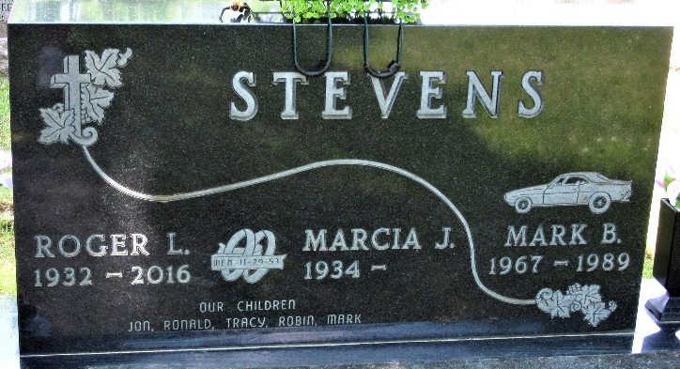
Photo by PLS

Mark B Stevens
in the Indiana, U.S., Death Certificates, 1899-2017
Name Mark B Stevens
Gender Male
Race White
Marital Status Never Married (Single)
Age 21
Birth Date 13 Dec 1967
Birth Place Decatur, Indiana
Death Date 13 Nov 1989; hunting accident
Death Place Decatur, Adams, Indiana, USA
Death Registration Date 1989
Father Roger L Stevens
Mother Marcia J Becker
Informant Roger Stevens; father; Decatur, Indiana
Burial November 16, 1989; Decatur Cemetery; Decatur, Indiana

