Marcia J. (Becker) Stevens
March 18, 1934 – November 10, 2004

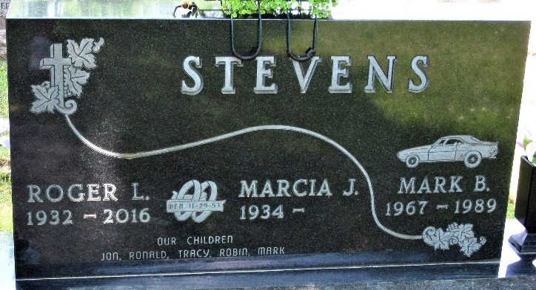
Photo by PLS

Marcia J. Becker from tree Miller Family Tree
Birth 18 Mar 1934 Van Wert, Van Wert, Ohio, USA
Marriage 10 Dec 1953 Van Wert, Van Wert, Ohio, USA
Death 10 Nov 2004
Father William Lester Becker (1907-1975)
Mother Pearl Wilhelmina Malinda Waterman (1908-1995)
Spouse Roger Lee Stevens (1932-2016)

