Lulu I. (Steele) Stevens
January 8, 1890 – March 4, 1923

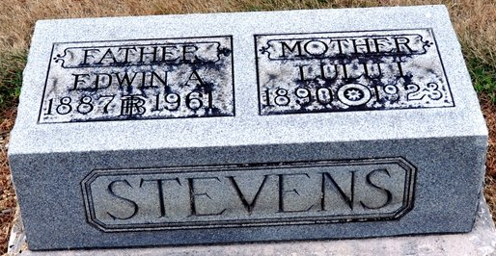
Photo by Deb Curry

LULU STEVENS DIED SUNDAY
Former Resident of Decatur Died in Ft. Wayne; Funeral Here Tuesday

Mrs. Lulu I. Stevens, age 33, former Decatur woman, wife of Edwin Stevens, died at her home, 1918 Weisser Park Avenue, Fort Wayne at 2:30 o’clock Sunday afternoon, following an illness of throat trouble and complications, resulting from an attack of the influenza. Mrs. Stevens took sick about two weeks ago and had been confined to her bed since that time. Prior to her fatal sickness members of her family were victims of diphtheria and the home was quarantined for some time.
The body will be brought to this city Tuesday afternoon and funeral services will be held at the Methodist Church at 2:30, the Rev. U. S. A. Bridge officiating. Burial will be made in the Maplewood Cemetery. The W.R.T. and members of the Ladies Auxiliary of the Methodist Church of Fort Wayne will accompany the body to this city.
Mrs. Stevens was born at Pleasant Mills on January 28, 1890, a daughter of Mr. and Mrs. Ira Steele of Lake Otis, Michigan. When a young girl she moved to this city and on April17, 1908 was married to Edwin Stevens. To this union four sons were born, they being, Robert, Edwin Jr., Bruce and Adrian, all of whom survive, besides the husband and two brothers, Marion and Hubert Steele, of Fort Wayne, and two sisters, Mrs. W.K. Hughes of Springfield, Ohio, and Mrs. Fred Bliss of Kalamazoo, Mich. Mr. Stevens is the son of Henry Stevens of this city.
Prior to leaving Fort Wayne with the body, short funeral services will be held at the Stevens home at 12:30 o’clock.

Decatur Daily Democrat, Adams County, Indiana
Monday, March 5, 1923
**
Indiana, U.S., Death Certificates, 1899-2017
Name Lulu J Stevens
[Lulu J Steele]
Gender Female
Race White
Marital Status Married
Age 33
Birth Date 8 Jan 1890
Birth Place Indiana
Death Date 4 Mar 1923
Death Place Fort Wayne, Allen, Indiana, USA
Death Registration Date 1923
Father Ira Steele
Mother Oskaloose Wians
Spouse Edwin Stevens
Informant Edwin Steele; Fort Wayne, Indiana
Burial March 6, 1923; Decatur, Indiana

