Joseph Dennison Stevens
August 22, 1886 – November 17, 1926

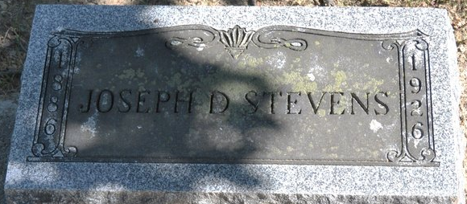
Photo by Deb Curry

Joseph Denny Stevens, son of Smith and Jane Crozier Stevens, was born in Adams County, Indiana August 22, 1886. Died in Clair County, Michigan November 18, 1926. Aged 40 years, 2 months and 26 days.
In early manhood he was united in marriage to Miss Clara Koos and to this union were born three children, Beatrice, Thelma and Blanche. Beatrice dying in infancy and this union was severed by the death of the wife.
On March 14, 1917, he was married to Matie Chronister and to this union were born seven children, two of these, Elizabeth and Helen, dying in infancy. The children of this marriage who survive being Joseph, Chester, Mildred, Merle, Veda, Ruth and Donald D.
In April 1919, he removed to Harrison, Michigan where he has been engaged in the garage and gasoline station business.
Several years ago he united with the United Brethren Church at Decatur, Indiana from which church the funeral services were held Wednesday afternoon and burial made in the Decatur Cemetery. The Rev. Cecil R. Smith officiating.
Besides the immediate family of widow and children, there survives four sisters, Mrs. Primallio Wise, and Mrs. Ruth Webster of Decatur, Mrs. Ethel Roth of Van Wert, Ohio and Mrs. Mary L. Fieroe of Dixon, Ohio, one brother, Clinton Stevens of this city.

Decatur Daily Democrat, Adams County, Indiana
November 26, 1926

**
Death • Michigan, Death Certificates, 1921-1952

Name Joseph Stevens
Age 40
Birthplace Adams, Indiana
Marital Status Married
Father's Name Smith Stevens
Mother's Name Jane Crozier
Event Type Death
Event Date 17 Nov 1926
Event Place Hayes, Clare, Michigan, United States
Microfilm Number 001973218

