John Newton Stevens
September 19, 1879 – March 14, 1915

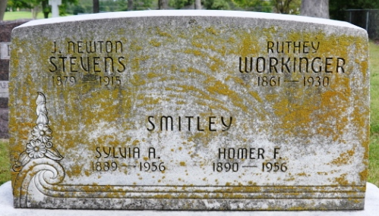
Photo by Deb Curry

Proved Fatal
Pneumonia and Heart trouble Cause of Death of John Newton Stevens
Of Union Township
Was Thirty-Five Years old and Well-Known Young Man – Relatives Here

Pneumonia with complications of heart trouble proved fatal Sunday morning at 7 o’clock for John Newton Stevens, a well-known young man of Union Township residing near the state line. He had been ill of pneumonia but seemed to be getting along well until Sunday morning when the heart became so weakened that heart failure resulted.
Mr. Stevens was in the very prime of life, being but thirty-five years, five months and twenty-five days old. He was born September 19, 1879. He was the son of Mr. and Mrs. Smith Stevens. He resided on the Clark Brothers farm across from the old Stevens homestead.
Mr. Stevens was a man of exemplary character and well liked.
The wife and two daughters, Esther, aged five years and Dortha, aged nineteen months feel the loss of husband and father. The parents and the following brothers and sisters are also greatly bereaved: (cut off)

Decatur Daily Democrat, Adams County, Indiana
March 15, 1915

**
Indiana, U.S., Death Certificates, 1899-2017
Name John Newton Stevens
Gender Male
Race White
Marital Status Married
Age 35
Birth Date 19 Sep 1879
Birth Place Union T.P. Adams Co Indiana
Death Date 14 Mar 1915
Death Place Indiana, USA
Death Registration Date 1910-1919
Father Smith Stevens
Mother Sarah J. Crozier
Spouse Sylvia Ardelle Chronister
Informant Cut off
Burial Cut off

