Jennie (Somers) Stevens
March 13, 1856 – January 31, 1936

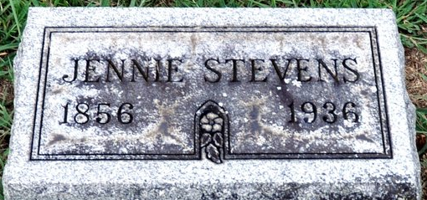
Photo by Deb Curry

Death • Michigan, Death Certificates, 1921-1952
Name Jennie Stevens
Sex Female
Age 79 years
Birth Date 13 March 1856
Birthplace Ohio
Marital Status Widowed
Father's Name Henry Somers
Father's Sex Male
Mother's Name Sarah Harvy
Mother's Sex Female
Event Type Death
Event Date 31 January 1936
Event Place Kalamazoo, Kalamazoo, Michigan, United States

