Henry W. Stevens
October 24, 1853 – March 27, 1932

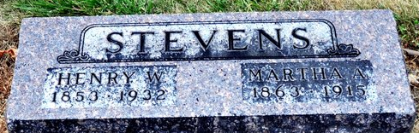
Photo by Deb Curry

Henry Stevens
in the Illinois, U.S., Deaths and Stillbirths Index, 1916-1947
Name Henry Stevens
Birth Date 24 Oct 1853
Birth Place Decatur, Ind
Death Date 27 Mar 1932
Death Place Chicago, Cook, Illinois
Burial Date 28 Mar 1932
Burial Place Decatur, Adams, Indiana
Cemetery Name Maplewood
Death Age 78
Occupation Contractor, Sewage
Race White
Marital Status W
Gender Male
Residence Chicago, Cook, Illinois
Father Name John Stevens
Father Birth Place Penn.
Spouse Name Marthe Ann
Comments In city 2y 6m
FHL Film Number 1893250

