Francis L. (Hess) Stevens
June 11, 1934 – January 1, 2019

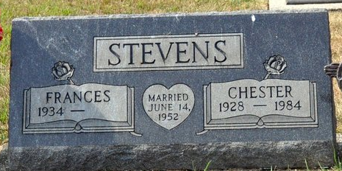
Photo by Deb Curry

Frances L. Stevens, 84, of Decatur, Indiana passed away Tuesday morning, January 1, 2019 at Adams Woodcrest. She was born on June 11, 1934 in Decatur, Indiana to Harold & Margaret (Hirschy) Hess. She married Chester W. Stevens in June of 1952 and he preceded her in death in 1984.
Frances was a homemaker and had worked at Walmart in Decatur for several years. She loved to play BINGO and do puzzles.
She is survived by two daughters, Betty (Robert) Hess of Decatur & Jeannie Stevens of New Haven; four sons, Chester (Patty) Stevens, Jr. & Jerry (Cheryl) Stevens both of Decatur, Ronnie L. (Nancy) Stevens & Nicholas (Dawn) Stevens both of Berne; sister, Ruth Smith of Decatur; 12 grandchildren; eight great-grandchildren; & six great-great-grandchildren. She was preceded in death by two sisters, Kate Evans & Mary Bailey and a brother, Rueben “Bud” Hess.
A funeral service will be held at 3:00 p.m. Friday, January 4, 2019 at Zwick & Jahn Funeral Home in Decatur with visitation from 1 to 3 p.m. Pastor Melissa Fisher to officiate. Interment will follow at Decatur Cemetery.
Preferred memorials are to Alzheimer’s Research.

Zwick & Jahn Funeral Home, Adams County, Indiana
Tuesday, January 1, 2020

