Elwood Stevens
June 27, 1882 – April 6, 1956

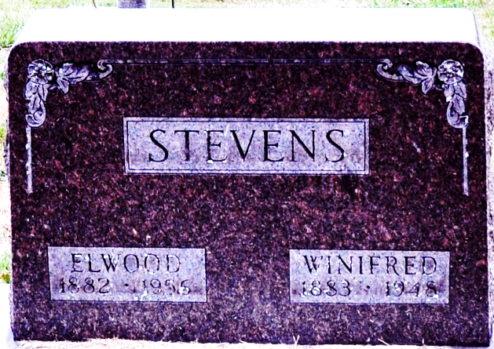
Photo by Deb Curry

Elwood Stevens
in the Michigan, U.S., Deaths and Burials Index, 1867-1995
Name Elwood Stevens
Birth Date 27 Jun 1882
Birth Place Ind.
Death Date 6 Apr 1956
Death Place St. Joseph
Burial Date 9 Apr 1956
Burial Place Decatur Adams, Ind.
Cemetery Name Decatur Cemetery
Death Age 73
Race White
Marital Status Widowed
Gender Male
Street Address 500 Wenzel, Sturgis
Residence St. Joseph, Michigan
Father Name Aaron Stevens
Mother Name Jennie Summers
Spouse Name Winifred Russell Stevens
FHL Film Number 1940446

