Elizabeth Viola (Harker) Stevens
September 9, 1882 – January 10, 1961

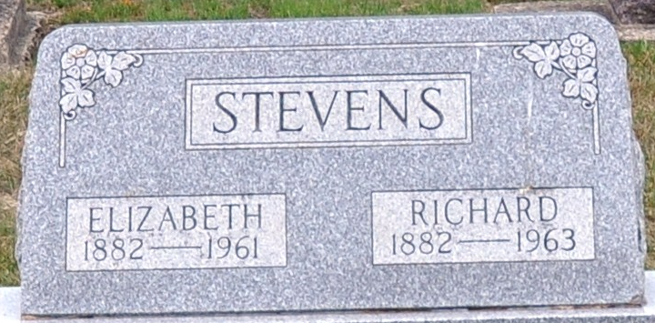
Photo by Deb Curry

Elizabeth Viola Stevens
in the Indiana, U.S., Death Certificates, 1899-2017
Name Elizabeth Viola Stevens
[Elizabeth Viola Harker]
Gender Female
Race White
Marital Status Married
Age 78
Birth Date 9 Sep 1882
Birth Place Ohio
Death Date 10 Jan 1961
Death Place Decatur, Adams, Indiana, USA
Death Registration Date 1961
Father Adam Harker
Mother Charlotte Brown
Informant Richard Stevens; husband; Decatur, Indiana
Burial January 13, 1961; Decatur Cemetery; Decatur, Indiana

