Edwin A. Stevens
October 26, 1887 – August 31, 1961

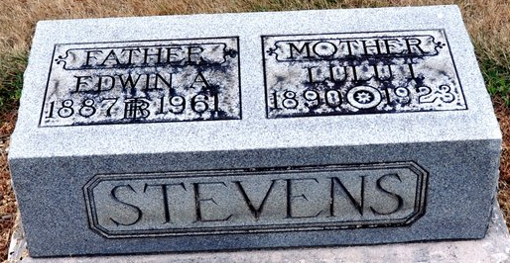
Photo by Deb Curry

Edwin A Stevens
in the Indiana, U.S., Death Certificates, 1899-2017
Name Edwin A Stevens
Gender Male
Race White
Marital Status Widowed
Age 73
Birth Date 26 Oct 1887
Birth Place Decatur, Indiana
Death Date 31 Aug 1961
Death Place Fort Wayne, Allen, Indiana, USA
Death Registration Date 1961
Father Henry Stevens
Mother Martha Bolt
Informant Bruce Stevens; son; Fort Wayne, Indiana
Burial September 3, 1961; Decatur Cemetery; Decatur, Indiana

