Clinton L. Stevens
February 11, 1890 – March 31, 1961

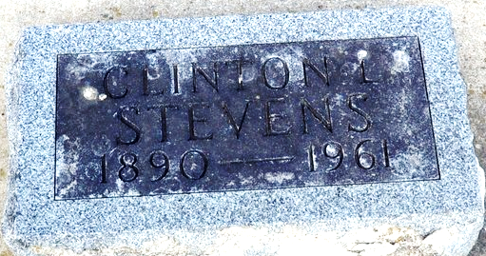
Photo by Deb Curry

Clinton L Stevens
in the Ohio, U.S., Death Records, 1908-1932, 1938-2022
Name Clinton L Stevens
Gender Male
Race White
Marital Status Divorced
Death Age 71
Birth Date Abt 1890
Residence Place Van Wert, Ohio, USA
Death Date 31 Mar 1961
Death Place Van Wert, Van Wert, Ohio, USA
Certificate Number 22554
Inquest Hospital Van Wert County Hospital
Inquest Questions Certifier: Physician; Autopsy Performed?: Yes, Used For Certification;
**
Indiana, U.S., Marriages, 1810-2001
Name Clinton Stevens
Gender Male
Race White
Age 35
Event Type Marriage Registration (Marriage)
Birth Date 11 Feb 1890
Birth Place Union Township
Marriage Date 1 Aug 1925
Marriage Place Indiana, United States
Residence Place Decatur, Indiana
Father Smith Stevens
Mother Sarah Jane Crozier
Spouse Mary Harvey Wilson
Page 424
FHL Film Number 002321631

