Clarence Stevens
July 22, 1892 – June 26, 1969

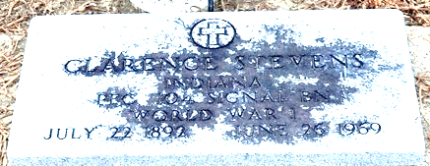
Photo by Deb Curry

Clarence Stevens Dies Last Evening

Clarence Stevens, 76, long time employee of the Decatur City Light Utility until his retirement, died at 5:45 p.m. Thursday at his home, 403 South Fifth Street, following an extended illness.
He was born in Decatur July 22, 1892, a son of Henry and Martha DeBolt-Stevens, and was a lifelong resident of this city.
Mr. Stevens was a World War I veteran and a member of the American Legion.
Surviving is his wife, Charlotte Ladd Stevens, and a sister, Mrs. Ada Overholser of Chicago, Ill. One sister and one brother are deceased.
Funeral services will be conducted at 2 p.m. Saturday at the Winteregg-Linn Funeral Home, with Rev. Donald Kime officiating. Burial will be in the Decatur Cemetery. Friends may call at the funeral home after 7 p.m. today until time of the services.

Decatur Daily Democrat, Adams County, Indiana
Friday, June 27, 1969

