Clara Mae (Koos) Stevens
June 24, 1889 – July 26, 1913

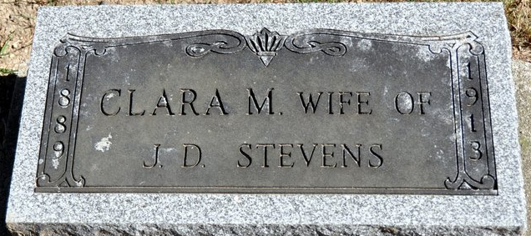
Photo by Deb Curry

Funeral Held Today
For Mrs. Joseph Stevens at the United Brethren Church

The funeral services for Mrs. Joseph Stevens were held this afternoon at 2 o’clock at the United Brethren Church by the Rev. L. W. Love. Interment in the Decatur Cemetery.
Mrs. Stevens death occurred Saturday noon from heart trouble after an illness of two weeks. The deceased was well and favorably known and the funeral was very largely attended.
Mrs. Stevens was formerly Miss Clara Koos of near Rivarre.

Decatur Democrat, Adams County, Indiana
July 28, 1913

**
Indiana, U.S., Death Certificates, 1899-2017 (Bad image)
Name Clara May Koos Stevens
Gender Female
Race White
Age 24
Birth Date 24 Jan/June? 1889
Birth Place Adams County, Indiana
Death Date Jul 1913
Death Place Decatur, Adams, Indiana, USA
Death Registration Date 1913
Father Geo Koos
Mother ? Lillich
Spouse Jos D Stevens
Informant Jos. Stevens; Decatur, Indiana
Burial ??

