Chester W. Stevens, Sr.
May 23, 1928 – May 8, 1984

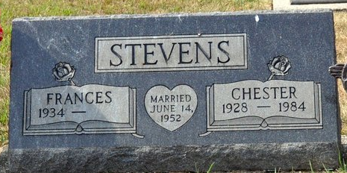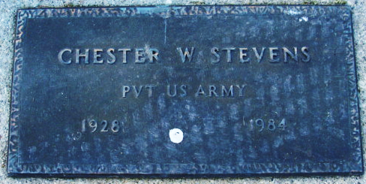
Photo by Deb Curry

Chester W. Stevens Sr
in the Indiana, U.S., Death Certificates, 1899-2017
Name Chester W. Stevens Sr
Gender Male
Race White
Marital Status Married
Age 55
Birth Date 23 May 1928
Birth Place Ohio
Death Date 8 May 1984
Death Place Decatur, Adams, Indiana, USA
Death Registration Date 1984
Father Lloyd E. Stevens
Mother Serena Evans
Spouse Frances L. Hess
Informant Mrs. Frances Stevens; wife; Decatur, Indiana
Burial May 11, 1984; Decatur Cemetery; Decatur, Indiana

