Chalmer J. Stevens
January 23, 1912 – June 14, 1988

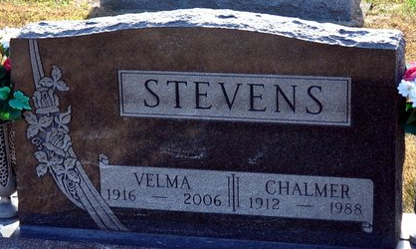
Photo by Deb Curry

Chalmer J Stevens
in the Indiana, U.S., Death Certificates, 1899-2017
Name Chalmer J Stevens
Gender Male
Race White
Marital Status Married
Age 76
Birth Date 23 Jan 1912
Birth Place Van Wert County, Ohio
Death Date 14 Jun 1988
Death Place Decatur, Adams, Indiana, USA
Death Registration Date 1988
Father Richard S Stevens
Mother Elizabeth Harker
Spouse Velma Kelley
Informant Velma Stevens; wife; Decatur, Indiana
Burial June 17, 1988; Decatur Cemetery; Decatur, Indiana

