Arlene K. (Stetler) Stevens
February 10, 1947 – June 12, 2015

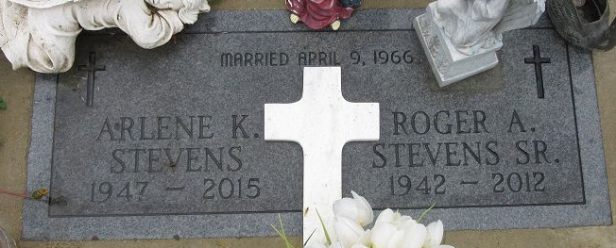
Photo by PLS

Arlene K. Stevens, 68 years old of Decatur, Indiana, passed away on Friday, June 12, 2015 at her residence. She was born on Monday, February 10, 1947 in Adams County, Indiana the daughter of LaVerne L. Stetler and the late Betty L. (Brewster) Stetler. She married Roger A. Stevens on April 9, 1966 and he preceded her in death on June 15, 2012.
Arlene attended Damascus Road Church in Decatur.
She was a homemaker and a CNA that had previously worked in home health.
Surviving are her father, LaVerne L. Stetler of Decatur; daughter, Pamela S. (Jim) McCullough of Decatur; daughter, April A. (Gary) Lautzenheiser of Muncie; son, LaVerne D. (Jonetta) Stevens of Portland; son, Roger A. (Ellen) Stevens, Jr. of Decatur; son, David A. Stevens of Decatur; and sister, Mary L. Stetler of Decatur. She is also survived by 16 grandchildren; 22 great-grandchildren; and two great-grandchildren on the way.
Preceding Arlene in death were five great-grandchildren.
Funeral services will be held at 7:00 p.m. Tuesday, June 16, 2015 in the Zwick & Jahn Funeral Home in Decatur with Pastor Kevin Mahlan officiating. Interment will take place at Decatur Cemetery at 1:00 p.m. on Wednesday, June 17, 2015. Friends will be received from 4 to 7 p.m., Tuesday, June 16 in the Zwick & Jahn Funeral Home in Decatur. Preferred memorials are to the family.

Zwick & Jahn Funeral Home, Adams County, Indiana
June 13, 2015

