Alice Stevens
February 28, 1910 – December 5, 1910

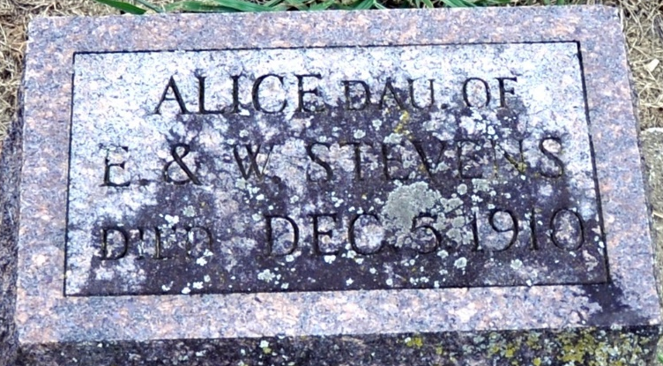
Photo by Deb Curry

Alice Stevens
in the Indiana, U.S., Death Certificates, 1899-2017
Name Alice Stevens
Gender Female
Race White
Age 9 months, 7 days
Birth Date 28 Feb 1910
Birth Place Adams County, Indiana
Death Date 5 Dec 1910
Death Place Decatur, Adams, Indiana, USA
Death Registration Date 1910
Father Elwood Stevens
Mother Winfred Russell
Informant Elwood Stevens; Decatur, Indiana
Burial December 7, 1910; City Cemetery

