Aaron Carpenter Stevens
January 20, 1858 – December 20, 1932

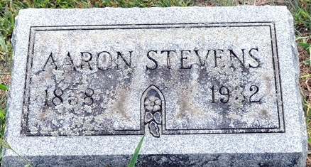
Photo by Deb Curry

Death Claims Aaron Stevens
Apoplexy Proves Fatal to Aged Decatur Man; Suffers Stroke Saturday

Aaron Stevens, 74, lifelong resident of Adams County, died at his home at 1109 West Elm Street Tuesday afternoon at 2:15 o’clock following a stroke of apoplexy which he suffered early Saturday evening.
Mr. Stevens had been employed for many years at the Krick-Tyndall Tile Company and in the last several years at the LaFontaine Handle Factory.
Aaron Carpenter Stevens was born in Adams County on January 20, 1868 [sic), the son of James and Sarah McHorter Stevens. He was the only child left in the family of twelve children. His brother, James of Sherwood, Michigan preceded him in death three weeks ago.
Mr. Stevens entire life was spent in Adams County; He moved to Decatur from Union Township in 1899. In 1879, he was united in marriage to Jennie Summers, who survives, together with five children: Elwood of Sturgis, Michigan, Mrs. Blanche Logan of Kalamazoo, Michigan, Hugh of Lakeside, Oregon, Harve, at home and Zelna Davisson of Anderson.
Fifteen grandchildren and one great grandchild also survive. Mr. Stevens was a member of the First United Brethren Church.
Funeral services will be held Thursday afternoon at 1:30 o’clock at the home on Elm Street and at 2 o’clock at the Christian Brethen Church, with the Rev. C. J. Roberts officiating. Burial will be made in the Decatur Cemetery.

Decatur Daily Democrat, Adams County, Indiana
December 21, 1932

**
Indiana, U.S., Death Certificates, 1899-2017
Name Arron Stevens
Gender Male
Race White
Marital Status Married
Age 94
Birth Date 20 Jan 1858
Birth Place Indiana
Death Date 20 Dec 1932
Death Place Decatur, Adams, Indiana, USA
Death Registration Date 1932
Father James Stevens
Mother Sarah McHarter
Spouse Jennie
Informant Jennie Stevens; Decatur, Indiana
Burial December 22, 1932; Decatur Cemetery

