Sarah Susanne Steury
October 16, 1978 – May 30, 1998

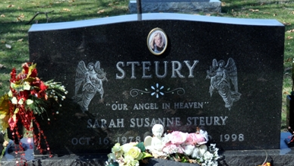
Photo by Deb Curry

Sarah Susanne Steury
in the Indiana, U.S., Death Certificates, 1899-2017
Name Sarah Susanne Steury
Gender Female
Race White
Marital Status Never Married (Single)
Age 19
Birth Date 16 Oct 1978
Birth Place Decatur, Indiana
Death Date 30 May 1998; auto accident
Death Place Decatur, Adams, Indiana, USA
Death Registration Date 1998
Father Richard W. Steury
Mother Linda S. Ehrsam
Informant Richard Steury; father; Decatur, Indiana
Burial June 3, 1998; Decatur Cemetery; Decatur, Indiana

