Patricia Ann (Mahlan) Steury
January 29, 1929 – June 26, 2009

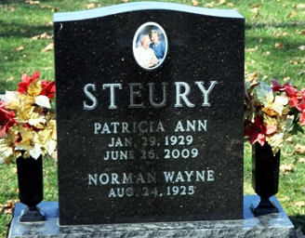
Photo by Deb Curry

Patricia Ann Steury, 80, of Decatur, died Friday, June 26, 2009, at home. Born in Fort Wayne, daughter of the late Henry and Stella Mahlan, she attended St. Paul's Lutheran School and graduated from Hoagland High School as Valedictorian in 1947.
Pat retired from Decatur Industries, Decatur, in 1982. She also lived in Lake Worth, Fla. for over 20 years; retiring from The Ark Restaurant in Lantana, Fla., in 1998. She was a member of Antioch Lutheran Church in Hoagland.
She is survived by her husband, Norman Steury; daughter, Barbara (John) Kowalczyk of Fort Wayne; son, Richard Steury of Decatur; grandchildren, Nick Steury of Decatur, Hannah Kowalczyk of Chicago, Ill. and Martha Kowalczyk of New York, N.Y.; brother, John Mahlan of Decatur; and sister, Sue Grotrian of Fort Wayne. She was also preceded in death by her granddaughter, Sarah Steury.
A memorial service is 11 a.m. Tuesday at Zwick & Jahn Funeral Home, Decatur, with the family receiving friends and family one hour prior to service. In lieu of flowers, preferred memorials to The Sarah Steury Scholarship Fund, Family Hospice and Palliative Care or Antioch Lutheran Church.

News-Sentinel, Allen County, Indiana
Sunday, June 28, 2009

**
Indiana, U.S., Death Certificates, 1899-2017
Name Patricia Ann Steury
[Patricia Ann Mahlan]
Gender Male
Race White
Marital Status Married
Age 80
Birth Date 29 Jan 1929
Birth Place Fort Wayne, Indiana
Death Date 26 Jun 2009
Death Place Decatur, Adams, Indiana, USA
Death Registration Date 2009
Father Henry Mahlan
Mother Stella Hockemeyer
Spouse Norman W Steury
Informant Norman W. Steury; husband; Decatur, Indiana
Cremation Northern Indiana Crematory; Fort Wayne, Indiana

