Norman Wayne Steury
August 24, 1925 -

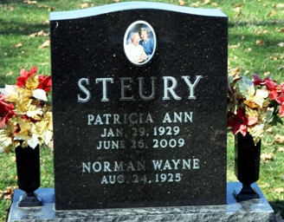
Photo by Deb Curry

Norman Wayne Steury
in the Indiana, U.S., Birth Certificates, 1907-1944
Name Norman Wayne Steury
Gender Male
Birth Date 24 Aug 1925
Birth Place Berne, Adams, Indiana, USA
Father Noah R Steury; age 25
Mother Amanda Graber; age 20; 1st child
Certificate Number 39313
Roll number 40474_357749
Volume Range 76 - 80

**
Norman Wayne Steury from tree Yoder-Rupp Families
Birth 24 Aug 1925 Berne, Adams, Indiana, USA
Residence 1940 Decatur, Adams, Indiana, USA
Marriage 8 Sep 1948 Indiana, USA
Father Noah Rudolph Steury (1899-1975)
Mother Amanda * Graber (1904-1997)
Spouse Patricia Ann Mahlan (1929-2009)
194835 People 4 Records 4 Sources

