Harvey Samuel Stetzel
March 6, 1881 – May 28, 1974

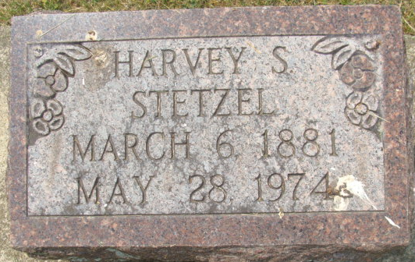
Photo by Alicia Kneuss

Harvey Stetzel Dies at Age 93
Harvey S. Stetzel, 93, of 810 North Third St., retired Indiana Service Co. employee, died at 11 p.m. Tuesday at the Adams County Memorial Hospital, following an extended illness. Mr. Stetzel retired in 1939. He was a member of the Church of Jesus Christ of Latter-day Saints.
Born in Huntington County on March 6, 1881, he was the son of David and Mary Jane Lantis-Stetzel, and was married to Cora Belle Lee, who died in 1942.
Surviving are seven children, Mrs. Lester (Lavaughn) Johnson of Decatur, with whom he made his home; Mrs. Mary Harter of Sturgis, Mich.; Mrs. Frank (Mabel) Adamczak of Tucson, Ariz.; Mrs. Bill (Nancy) Poole of Tucson, Ariz.; Mrs. Bill (Marcia) Hoffman of Decatur; Gaylord W. of Boulder, Montana; and Mrs. Wesley (Germanine) Dean of Somerset, Va.; 21 grandchildren and 24 great-grandchildren. One son, four daughters, four sisters, and two brothers preceded him in death.
Funeral services will be held Friday at 1 p.m. at the Winteregg-Linn and Haggard Funeral Home. Burial will be in the Decatur Cemetery. Friends may call at the funeral home after 2 p.m. Thursday.
Decatur Daily Democrat, Adams County, Indiana
Wednesday, May 29, 1974

