Cora (Lee) Stetzel
September 4, 1885 – January 17, 1946

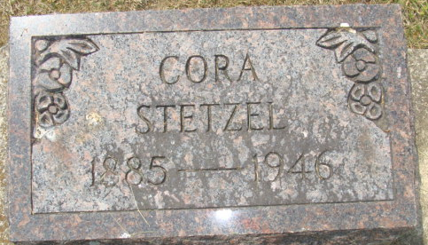
Photo by Alicia Kneuss

Mrs Cora Harvey
in the Indiana, U.S., Death Certificates, 1899-2017
Name Mrs Cora Stetzel
[Cora Lee]
Gender Female
Race White
Marital Status Married
Age 60
Birth Date 4 Sep 1885
Birth Place Decatur, Indiana
Death Date 17 Jan 1946
Death Place Decatur, Adams, Indiana, USA
Death Registration Date 1946
Father Henry Lee
Mother Nancy Diel [sic - Diehl]
Spouse Harvey Stetzel; age 64
Informant Harvey Stetzel; Monroeville, Indiana
Burial January 20, 1946; Maplewood Cemetery; Decatur, Indiana

