Clarence Henry Stetler
December 30, 1884 – November 11, 1945

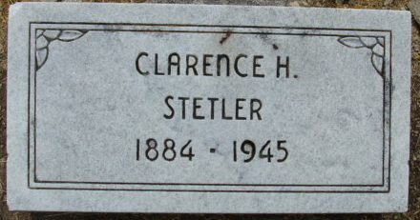
Photo by Alicia Kneuss

Collection: Ohio Deaths 1908-1953
Name: Clarence Henry Stetler
Death date: 11 Nov 1945; Death place: Painesville, Lake, Ohio
Birth date: 30 Dec 1884; Birthplace: Decatur, Ind
Age at death: 60 years 10 months 11 days; Gender: Male
Marital status: Married; Race or color: Caucasian
Spouse's name: Mary
Father's name: Homer Stetler
Mother's name: Emily Carter
GSU film number: 2372587; Digital GS number: 4072477; Image number: 02285; Reference number: 66891

