Rollin F. Stephenson
April 19, 1874 – March 26, 1896

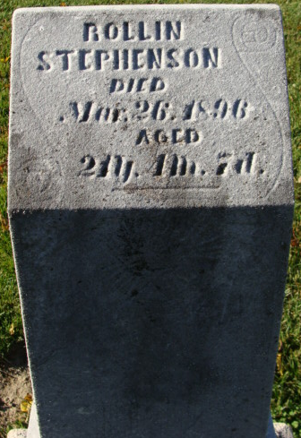
Photo by Alicia Kneuss

Rolla F Stephenson from tree LLRRoots
Birth 19 Apr 1874 Zionsville, Boone, Indiana, USA
Residence 1880 Montgomery, Indiana, USA
Marriage 4 May 1895 Uniondale, Wells, Indiana, USA
Death 26 Mar 1896 Adams, Indiana, USA
Father Henry O Stephenson (1849-1896)
Mother Martha C Baird (1844-1916)
Spouse Rozella May Taylor (1876-1970)

