Winoma E. (Everett) Steinhoff
December 27, 1907 – December 7, 1996

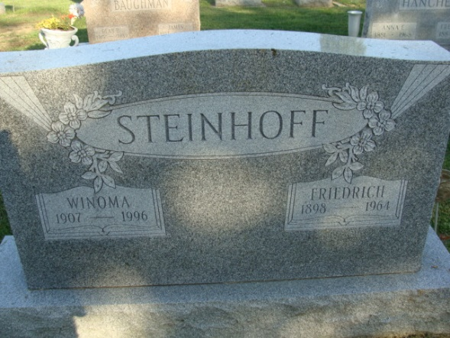
Photo by Alicia Kneuss

Winoma E. Steinhoff, 88, of Decatur died Saturday in Woodcrest Retirement Community. The Wren, Ohio, native formerly lived in Fort Wayne, retired in 1975 as a bookkeeper for Don Hall's Restaurants after 31 years and was the widow of Friedrich, who died in 1964.
Surviving are sisters, Evangeline ''Babe'' Gephart and Florine D. Thatcher, both of Decatur, Betty R. Holloway of San Bruno, Calif.; and Alice E. LeRoy of Sacramento, Calif.
Services are 2:30 p.m. Tuesday in Zwick-Sefton & Jahn Funeral Home, Decatur, where calling is 2 to 4 and 6 to 8 p.m. today. Burial will be in Decatur Cemetery.
Memorials are to Peace Lutheran Church, Fort Wayne, or Decatur Wesleyan Church.

News-Sentinel, Allen County, Indiana
Monday, December 9, 1996
**
Collection: Ohio Births and Christenings, 1821-1962
Name: Winoma Eva Everett
Gender: Female; Race: White
Birth Date: 27 Dec 1907; Birthplace: Willshire Twp., Van Wert, Ohio
Father's Name: Lester V. Everett
Mother's Name: Grace C. Cully
Indexing Project (Batch) Number: C05060-3; System Origin: Ohio-EASy; Source Film Number: 1015857; Reference Number: P.141 L.11

