Friedrich Steinhoff
April 26, 1898 – December 26, 1964

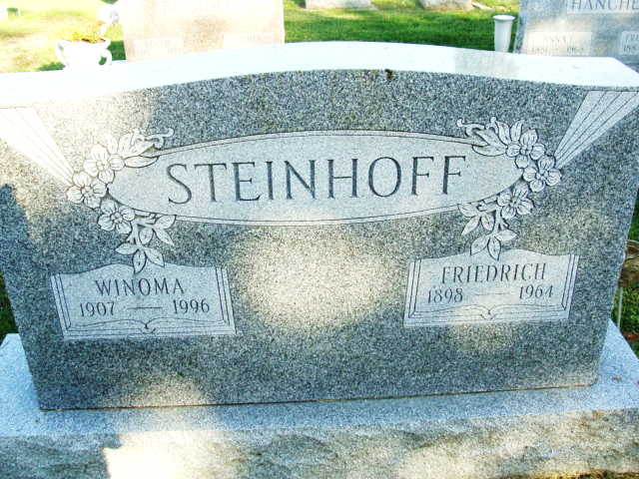
Photo by Alicia Kneuss

STEINHOFF RITES TO BE TOMORROW
Funeral services will be in Fort Wayne Tuesday for Friedrich (Fritz) Steinhoff, 66-year-old former Decatur resident who died Saturday at St. Joseph's hospital in that city.
Services will be held at 1:30 p.m. Tuesday in the Peace Lutheran church; Rev. Hartwig Schwehn officiating. Burial will be in the Decatur Cemetery. Friends may call at the Chalfant-Perry-Klaehn Funeral Home after 2 p.m. today until noon Tuesday when the body will be taken to the church.
Mr. Steinhoff died at 2:50 p.m. Saturday after being a patient at St. Joseph's for six days. A native of Hanover Province, Germany, he came to the United States and resided in this city until 1942, at which time he moved to Fort Wayne.
He was employed the past 15 years at Strataflo Products, Inc., in Fort Wayne, and worked at the Mutschler Packing Co. while residing in Detroit. A veteran of World War II, Mr. Steinhoff was a member of the Peace Lutheran Church, and preferred memorials are contributions to the church building fund.
Surviving include his wife, Winoma Everett, and a sister, Mrs. Karl Bertram, of Ohlen Rode, Germany.
Decatur Daily Democrat; Adams County, Indiana
Monday, December 28, 1964

**
Indiana, U.S., Death Certificates, 1899-2011
Name: Friedrich Steinhoff
Gender: Male; Race: White; Age: 66; Marital status: Married
Birth Date: 26 Apr 1898 Birth Place: Germany
Death Date: 26 Dec 1964’ Death Place: Fort Wayne, Allen, Indiana
Parents: Not named
Informant: Winona E. Steinhoff; wife; Fort Wayne, Indiana
Burial: December 29, 1964; Decatur Cemetery; Decatur, Indiana

