Frederick Steiner
April 8, 1928 – November 16, 1987

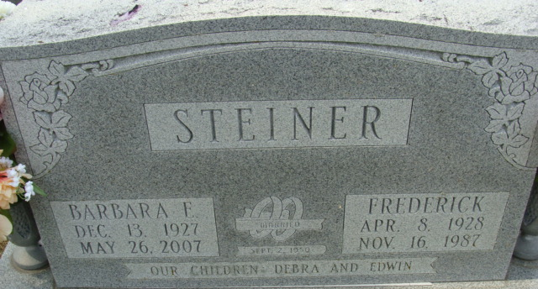
Photo by Alicia Kneuss

Frederick Steiner, 59, of route 5, died at 6:47 a.m. today in Adams County Memorial Hospital of a heart attack. He entered the hospital on Saturday. He was born in Adams County on April 8, 1928 to Hugo and Betty Frakes-Steiner and married the former Barbara Roop on September 12, 1950; she survives.
He was a self-employed metals broker and a member of Cross United Church of Christ in Berne.
Other survivors include a daughter, Debra Herdman of route 5; a son, Edwin Steiner of Decatur; two half-sisters: Molly Schindler of rural Bluffton and Maxine Margoles of Long Beach, California; and three grandchildren. A half-brother, Dyke Shoup, is deceased.
Funeral arrangements are pending at Yager-Kirchhofer Funeral Home in Berne. Burial will be in Decatur Cemetery.

Decatur Daily Democrat, Adams County, Indiana
Monday, November 16, 1987
**
Services for Frederick Steiner, 59, route 5, Decatur, who died Monday, will be held at 2 p.m. Wednesday at Yager-Kirchhofer Funeral Home, Berne, Rev. William Huenemann officiating. Burial will be in Decatur Cemetery. Friends may call at the funeral home from 6-9 p.m. today and Wednesday from 9 a.m. until time of services.
Memorials are to the Cross United Church of Christ, Berne.
He was born in Huntington, West Virginia, not in Adams County as was stated in the obituary notice released to the Democrat Monday.

Decatur Daily Democrat, Adams County, Indiana
Tuesday, November 17, 1987

