DeWayne Steiner
August 7, 1926 – October 12, 2019

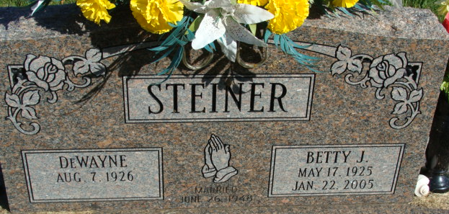
Photo by Alicia Kneuss

DeWayne Steiner, 93, of Decatur, Indiana passed away Saturday morning, October 12, 2019, at Lutheran Hospital in Fort Wayne.
He was born on August 7, 1926 in Adams County, Indiana to Tilman and Elma (Lehman) Steiner. On June 26, 1948, he married Betty Jean Wilson and she preceded him in death on January 22, 2005.
He served his country in the United States Army.
DeWayne was employed by Adams County Trailer Sales for 33 years, retiring in 1990. He owned and operated Quality Service Center for six years and worked part-time for Courtesy Motors for 27 years.
He was a long time member of the Decatur Church of God where he served as chairman of several boards and taught Sunday school for 48 years. DeWayne had also previously served the church as a janitor.
DeWayne loved gardening and could fix anything. He was a wonderful carpenter and made many things for others. He loved going to watch his grandchildren, great-grandchildren, and even his great-great-grandchildren play sports. He also loved watching IU basketball and Indianapolis Colts football.
He is survived by his son, Jerry L. (Pat) Steiner of Decatur; daughter, Terri S. Harrison of Northport, NY; grandson, Jerry Lee (Ada) Steiner II of Decatur; granddaughter, Kathy Roop of Decatur; great-grandchildren, Jerry Lee Steiner III, Hope (Nathan) Hunter, Lydia Roop, Bryce Roop, & Zayne Roop; & great-great-grandchildren, Jaxon, Lyla & Ellie Hunter.
He was preceded in death by his sister, Eileen Stauffer.
A funeral service will be held at 11:00 a.m. Wednesday, October 16, 2019, at Decatur Church of God with Pastor Don Smith officiating. Burial will follow at Decatur Cemetery with Military Graveside Services conducted by the American Legion Post #43 of Decatur.
Family & friends will be received from 5 to 8 p.m. Tuesday, October 15, 2019, at Zwick & Jahn Funeral Home in Decatur & one hour prior to the service at the church on Wednesday.
Preferred memorials are to Decatur Church of God Children's Ministry.

Zwick & Jahn Funeral Home, Adams County, Indiana
October 13, 2019

