Barbara E. (Roop) Steiner-Clark
December 13, 1927 – May 26, 2007

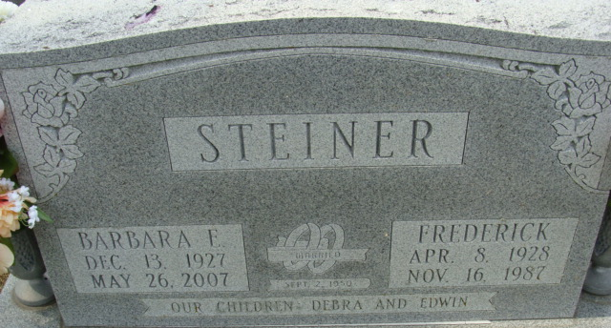
Photo by Alicia Kneuss

Barbara E. Steiner Clark, 79 of Monroeville, IN (formerly of a lifelong resident of Decatur) passed away at The Village of Heritage in Monroeville, IN on Saturday, May 26, 2007. Barbara was born on December 13, 1927 in Adams County, IN to Lawrence and Evaline (Butcher) Roop. She married Frederick Steiner on September 2, 1950, he passed away on November 16, 1987.
She is survived by 1 son Edwin L. (Nancy) Steiner of Decatur, IN; 1 daughter Mrs. James (Debra) Brown of Decatur, IN; 3 grandchildren & 5 great grandchildren.
She was a member of St. Mark's United Methodist Church. She worked at Montgomery-Wards in Fort Wayne, Fleetwood Motor Homes in Decatur and was the co-owner of Bright Way Commercial Cleaning.
Visitation is from 3:00 – 6:00 p.m. on Wednesday, May 30, 2007 at Haggard & Sefton Funeral Home. The funeral service will be held at 10:00 a.m. on Thursday, May 31, 2007 at Haggard & Sefton Funeral Home. Officiating will be the Rev. Fuhrman Miller, with burial in the Decatur Cemetery.
Memorials may be made to St. Mark's United Methodist Church or Juke Box Fund at Village of Heritage.

Haggard & Sefton Funeral Home, Adams County, Indiana
May 27, 2007

