Betty J. (Wilson) Steiner
May 17, 1925 – January 22, 2005

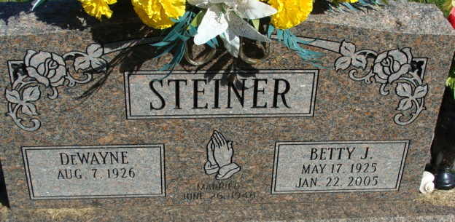
Photos by Alicia Kneuss

Betty J Steiner
in the Indiana, Death Certificates, 1899-2011
Name: Betty J Steiner
[Betty J Wilson]
Gender: Female
Race: White
Age: 79
Marital status: Married
Birth Date: 17 May 1925
Birth Place: Antwerp, Ohio
Death Date: 22 Jan 2005
Death Place: Decatur, Adams, Indiana , USA
Father: Frank Wilson
Mother: Madonna McCurdy
Spouse: DeWayne Steiner
Informant: DeWayne Steiner; husband; Decatur, Ind.
Burial: Jan. 26, 2005; Decatur Cem., Decatur, Ind.

