Lillian Stegbauer
November 17, 1901 – August 16, 1988

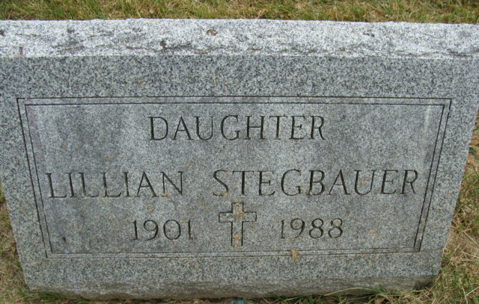
Photo by Alicia Kneuss

Lillian Stegbauer
in the Indiana, U.S., Death Certificates, 1899-2017
Name Lillian Stegbauer
Gender Female
Race White
Marital Status Never Married (Single)
Age 86
Birth Date 17 Nov 1901
Birth Place Chicago, Illinois
Death Date 16 Aug 1988
Death Place Berne, Adams, Indiana, USA
Death Registration Date 1988
Father Joseph Stegbauer
Mother Bertha Dadee
Informant Brice Bauserman; friend; Berne, Indiana
Burial August 18, 1988; Decatur Cemetery; Decatur, Indiana

