Leslie C. Stegbauer
August 28, 1905 – March 29, 1978

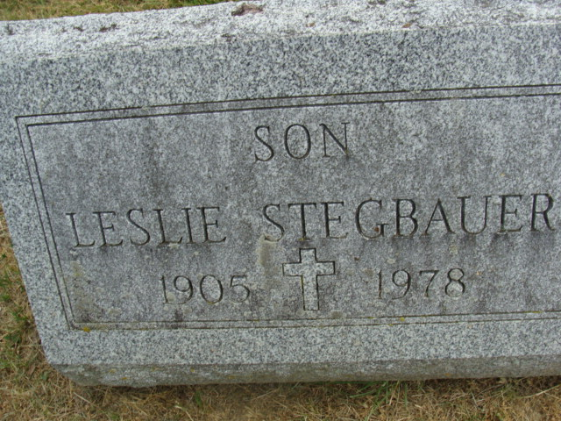
Photo by Alicia Kneuss

Leslie C Stegbauer
in the Indiana, U.S., Death Certificates, 1899-2017

Name Leslie C Stegbauer
Gender Male
Race White
Marital Status Never Married (Single)
Age 72
Birth Date 28 Aug 1905
Birth Place Illinois
Death Date 29 Mar 1978
Death Place Bluffton, Wells, Indiana, USA
Death Registration Date 1978
Father Joseph Stegbauer
Mother Bertha Dadee
Informant Lillian Stegbauer; Bluffton, Indiana
Burial March 30, 1978; Decatur Cemetery; Decatur, Indiana

