Joseph Stegbauer
1871 - 1941

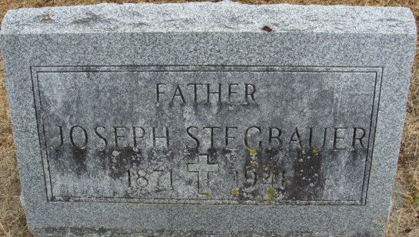
Photo by Alicia Kneuss

No further information found at this time

