Bertha (Doede) Stegbauer
December 31, 1868 – February 27, 1954

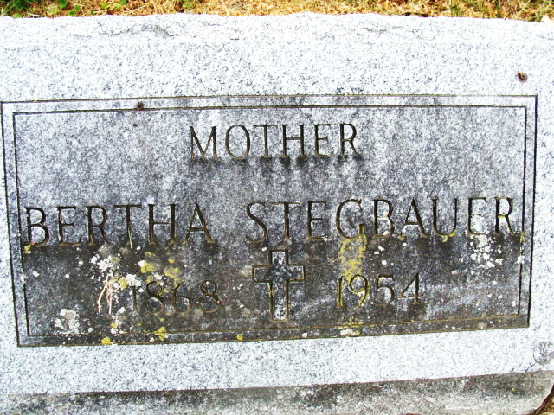
Photo by Alicia Kneuss

Bertha Stegbauer
in the Indiana, U.S., Death Certificates, 1899-2017
Name Bertha Stegbauer
[Bertha Doede]
Gender Female
Race White
Marital Status Widowed
Age 85
Birth Date 31 Dec 1868
Birth Place Wisconsin
Death Date 27 Feb 1954
Death Place Fort Wayne, Allen, Indiana, USA
Death Registration Date 1954
Father August Doede
Mother Justina Zellmer
Informant Miss Lillian Stegbauer
Burial March 2, 1954; Maplewood Cemetery; Decatur, Indiana

