Sarah (Valentine) Steele
February 15, 1819 – June 3, 1893

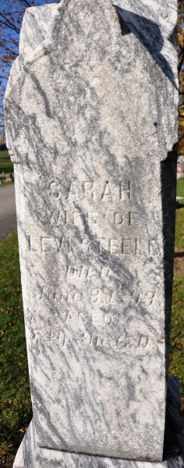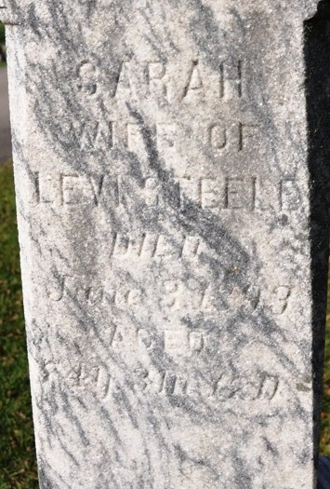
Photo by Deb Curry

Sarah Steele was born in Cumberland County, Pennsylvania, on February 15, 1819 and died at the home of her son, Dayton Steele, of this city, June 3, 1893, age 74 years, 3 months and 18 days. She was married to Levi Steele October 19, 1837, her maiden being Sarah Barkley [sic], to them were born eleven children, five sons and six daughters, the husband and six of the children before her were called from labor to reward.
Her husband died June 3, 1886, just seven years previous, she becoming tired of the pains, cares and anxieties of life, left earth for her long home in heaven. She was converted at the age of nineteen, and for fifty-five years, professed faith in Christ.
Funeral services took place at the home of her son, on corner of Monroe and Ninth Streets, conducted by Rev. E. E. Davis, assisted by Revs. Roberts and Johnson.

Decatur Democrat, Adams County, Indiana
A weekly newspaper
Friday, June 9, 1893

