Sarah J. (Krick) Steele
May 17, 1861 – February 25, 1944

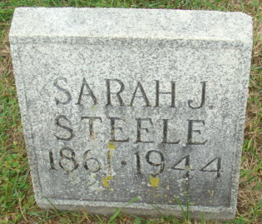
Photo by Alicia Kneuss
Funeral rites for Mrs. Sarah J. Steele, 83, who died following a long illness Friday at 7:30 a.m. at her home at 2118 Maumee Avenue, will be conducted Sunday at 2 p.m. at Klaehn & Sons Funeral Home, Rev. Charles Byrt officiating. Interment will be in the Maplewood Cemetery near Decatur. Friends may call at the funeral home after today noon.
Mrs. Steele was a member of the St. Paul Methodist Church.
Surviving are three sons, Morse, Arthur and Lawren Steele; two daughters, Mrs. Lana M. Gordon and Mrs. Herald Moore, all of Fort Wayne; eight grandchildren and three great-grandchildren.

Journal Gazette, Allen County, Indiana
Sunday, February 26, 1944

**
Indiana, U.S., Death Certificates, 1899-2017
Name Sarah J Steele
[Sarah J Krick]
Gender Female
Race White
Marital Status Widowed
Age 83
Birth Date 17 May 1861
Birth Place Paulding County, Ohio
Death Date 25 Feb 1944
Death Place Fort Wayne, Allen, Indiana, USA
Death Registration Date 1944
Father Elias Krich [sic]
Mother Mary Stevens
Spouse Samuel S. Steele; deceased
Informant Mrs. Lana M. Gordon; Fort Wayne, Indiana
Burial February 27, 1944; Maplewood Cemetery; Decatur, Indiana

