Samuel Levi Steele
August 11, 1844 – May 4, 1863

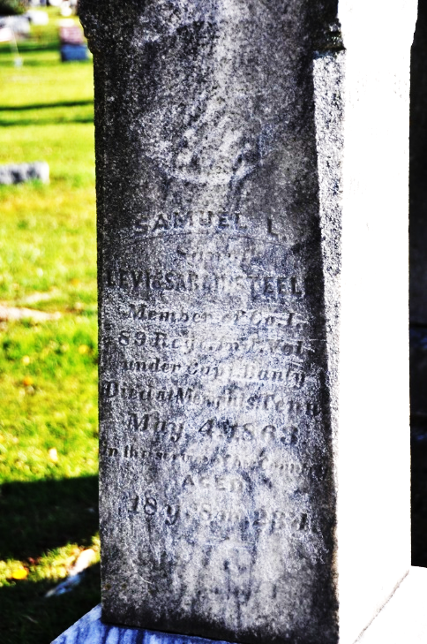
Photo by Deb Curry

Samuel Levi Steele from tree Smith Family Tree
Birth 11 Aug 1844 Ashland, Ohio, USA
Residence 1860 Mohican, Ashland, Ohio, USA
Death 4 May 1863 Memphis, Shelby, Tennessee, USA
Father Levi Steele (1818-1886)
Mother Sarah Valentine (1819-1893)

**
U.S., Civil War Roll of Honor, 1861-1865
Name: Samuel Steele
Death Date: 4 May 1863
Burial Place: Memphis, Tennessee, USA
Cemetery: Mississippi River National Cemetery
Rank: Private; Regiment: 89th Infantry; Company: I

