Roy C. Steele
June 19, 1890 – November 10, 1959

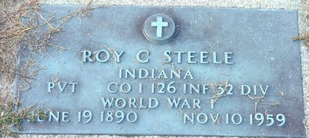
Photo by Deb Curry
Roy C. Steele Dies After Long Illness

Roy C. (Bud) Steele, 69, lifelong resident of Pleasant Mills, died at 10 o'clock Tuesday morning at the Veteran’s Hospital in Fort Wayne, where he had been a patient since May 2.
He was born at Pleasant Mills June 19, 1890, a son of Jesse and Niffie Cowan-Steele. He was employed as a carpenter.
A veteran of World War I, he entered service May 24, 1918, and was discharged May 26, 1919, after serving in France, Belgium, Holland and Germany. Mr. Steele was a member of the American Legion and the Veteran of Foreign Wars.
Surviving are six sisters, Mrs. Delbert (Edna) Tumbleson of Fort Wayne, Mrs. Burt (Maude) Holser of Walkerton, Mrs. Harvey (Gladys) Koos of Decatur, Mrs. Murray (Zula) Holloway of Pleasant Mills, Mrs. Lawrence (Lela) Robrock of Michigan City, and Mrs. Lawrence (Mary) Johnson of Middletown, O.; and two brothers, Guy Steele of Fort Wayne, and Joe Steele of Decatur.
Funeral services will be conducted at 2 p.m. Thursday at the Zwick Funeral Home, the Rev. Leon Lacoax officiating. Burial in the Decatur Cemetery. Friends may call at the funeral home until time of the service.

Decatur Daily Democrat, Adams County, Indiana
Wednesday, November 11, 1959

