Goldie (McKinney) Steele-Roth
September 29, 1874 – February 23, 1955

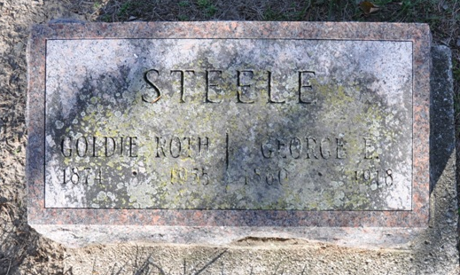
Photo by Deb Curry

Mrs Goldie Roth
in the Indiana, U.S., Death Certificates, 1899-2017
Name Mrs Goldie Roth
[Mrs Goldie McKinney]
Gender Female
Race White
Marital Status Married
Age 80
Birth Date 29 Sep 1874
Birth Place Indiana
Death Date 23 Feb 1955
Death Place Berne, Adams, Indiana, USA
Death Registration Date 1955
Father W C McKinney
Mother Mahala Chandler
Informant Ervin W. Steele; St. Mary's, Indiana
Burial February 25, 1955; Decatur Cemetery; Decatur, Indiana

