Niffie Blanche (Cowan) Steele
September 15, 1867 – July 5, 1959

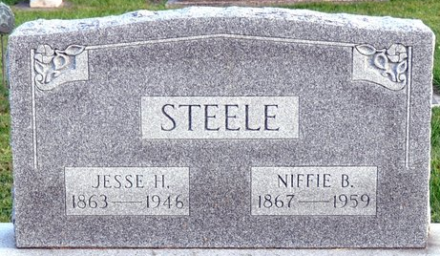
Photo by Deb Curry

Mrs. Jesse Steele Is Taken by Death
Mrs. Niffie Blanche Steele, 91, well known resident of Pleasant Mills all of her married life, died at 10:45 o'clock Sunday morning at the home of her daughter, Mrs. Harve Koos, 738 Mercer Avenue. She had been bedfast for the last six years.
She was born in Bobo Sept. 15, 1867, a daughter of Ezra and Sarah Death-Cowan, and was married to Jesse H. Steele July 11, 1885. Her husband preceded her in death April 28, 1946.
Mrs. Steele was a member of the Pleasant Mills Methodist Church and the W.S.C.S. of the church.
Surviving are six daughters, Mrs. Delbert (Edna) Tumbleson of Fort Wayne, Mrs. Bert (Maude) Holser of Walkerton, Mrs. Harvey (Gladys) Koos of Decatur, Mrs. Murray (Zula) Holloway of Pleasant Mills, Mrs. Lawrence (Lelah) Robrack of Michigan City, and Mrs. Lawrence (Mary) Johnson of Middletown, O.; three sons, Roy C. Steele of Pleasant Mills, Guy A. Steele of Fort Wayne, and Joe V. Steele of Decatur; 10 grandchildren; 14 great-grandchildren; and two great-great-grandchildren. Four daughters, one sister and three brothers are deceased.
Funeral services will be conducted at 2 p.m. Wednesday at the Zwick Funeral Home, the Rev. Leon Lacoax and the Rev. Emmett Anderson officiating. Burial will be in the Decatur Cemetery. Friends may call at the funeral home today after 7 p.m. until time of the services.

Decatur Daily Democrat, Adams County, Indiana
Monday, July 6, 1959

