Mary S. Steele
September 16, 1874 – June 7, 1951

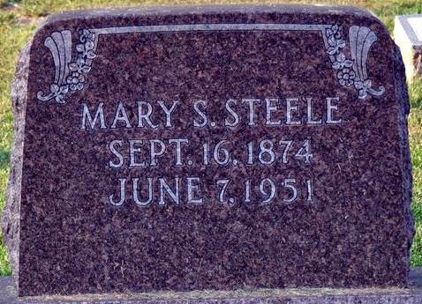
Photo by Deb Curry

Mary S Steele
in the Indiana, U.S., Death Certificates, 1899-2017
Name Mary S Steele
[Mary S Lebrun]
Gender Female
Race White
Marital Status Single
Age 76
Birth Date 16 Sep 1874
Birth Place Indiana
Death Date 7 Jun 1951
Death Place Decatur, Adams, Indiana, USA
Death Registration Date 1951
Father James Steele
Mother Victoria Lebrun
Informant Mrs. Cora Pense; Decatur, Indiana
Burial June 10, 1951; Decatur Cemetery; Decatur, Indiana

