Mary M. (Plummer) Steele
November 27, 1879 – October 14, 1973

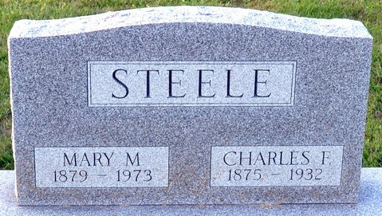
Photo by Deb Curry

Mary Steele, 93, Dies, Rites Tuesday

Mrs. Mary M. Steele, 93, of 122 North Ninth Street, died at 1:40 a.m. Sunday at her residence. She died following an extended illness and was in critical condition the past month.
Mrs. Steele, a member of the Jehovah Witness, was born in Wells County November 27, 1879, the daughter of George W. and Henrietta Trullender-Plummer, and was married December 14, 1902, to Charles F. Steele. He preceded her in death October 16, 1932.
Survivors include seven children, Mrs. Vance (Ida Mae) Clem, Sr., of Monroeville; Mrs. Fuhrman (Mary) Dellinger, of Willshire, O.; Chalmer Steele, of Bluffton; Edgar Steele, of Decatur; Clyde Steel, of Willshire, O.; Richard Steele, of Jonesboro, Ark., and Ralph Steele, of Fort Wayne; 12 grandchildren and 13 great-grandchildren. Two sisters and seven brothers preceded her in death.
Funeral services will be held at 2:30 p.m. Tuesday at the Winteregg-Linn Funeral Home with Roy Schwartz officiating. Burial will be in the Decatur Cemetery. Friends may call at the funeral home after 4 p.m. today.

Decatur Daily Democrat, Adams Co, Indiana
Monday, October 15, 1973

