Mary M. (Merryman) Steele
October 23, 1856 – December 12, 1940

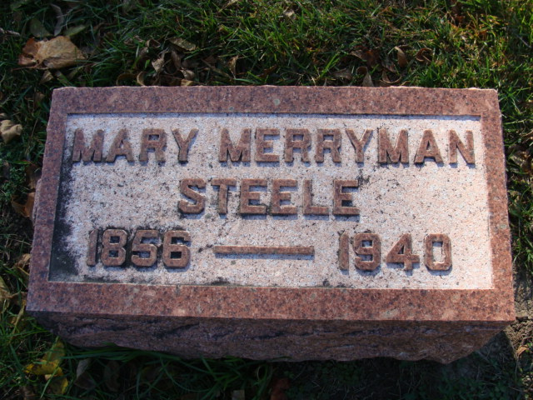
Photo by Alicia Kneuss

FORMER LOCAL RESIDENT DIES
Mrs. Mary M. Steele Dies at Memorial Home at Warren
Mrs. James (Mary M.) Steele, 84, for many years a well-known resident of Decatur and Adams County, died at 11:40 o'clock last night at the Methodist Memorial Home at Warren, where she had resided for the past three years. Death was attributed to a heart attack. She had been seriously ill for only a short time.
Mrs. Steele was born October 23, 1856, in Washington Township, Adams County, and for many years resided in Decatur where she took a prominent part in Methodist church work. Her husband preceded her in death several years ago.
Surviving are the following nephews: Walter M. Paulison, Evanston, Ill., Arthur M. Paulison and Orville Paulison, both of Fort Wayne, Harold and Herbert Merryman, Los Angeles, Cal., and Mrs. Floyd Ferguson, Fort Wayne, a niece and several stepchildren.
Funeral services will be held at the First Methodist church here at 1:30 o'clock Friday afternoon. Services will be conducted by Rev. D. C. Souder of the Methodist Memorial Home and Rev. Ralph W. Graham of the First Methodist Church. Burial will be in the Decatur Cemetery.

Decatur Daily Democrat, Adams County, Indiana
Thursday, December 12, 1940

**
Indiana, U.S., Death Certificates, 1899-2017
Name Mary M Steele
[Mary M Merryman]
Gender Female
Race White
Marital Status Widow
Age 84
Birth Date 23 Oct 1856
Birth Place Indiana
Death Date 12 Dec 1940
Death Place Warren, Huntington, Indiana, USA
Death Registration Date 1940
Father Zachariah Merryman
Mother Theresa Archbold
Informant J. E. Jenson; Supt. M. M. Home; Warren, Indiana
Burial December 13, 1940; Maplewood Cemetery; Decatur, Indiana

