Mary Elizabeth (Clear) Steele
February 19, 1842 – August 16, 1914

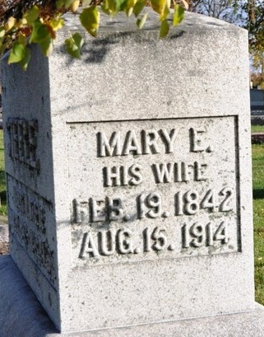
Photo by Deb Curry

NOBLE LIFE ENDS - Mary Elizabeth Steele, Wife of Albert N. Steel, Succumbs After a Long Illness - Was Seventy-Two Years Old --- Funeral Will be Wednesday Morning
A long and useful life of seventy-two years, five months and twenty-seven days, was brought to a close for Mary Elizabeth Steele, wife of Albert N. Steele, Sunday afternoon at 1:15 o'clock when she succumbed after a long illness. Mrs. Steele had been suffering from cancer for the past two years. An operation partially restored her to health but finally developed into cancer of the stomach. For fourteen weeks she had been worse. For seven weeks she had been bedfast, and her sufferings were very intense.
Mrs. Steele was a daughter of Henry and Sarah Clear and was born in Allen County, February 19, 1842. She was first married to Jacob Marquart long since deceased. Of the three children born to them, Isaac and Jacob died in infancy. One daughter, Mrs. Anna Laman of this city survives. Mrs. Marquart was then married to Albert N. Steele who is still living. For thirty years or more they have been residents of this city. At the time of her death and for many years prior, they have resided at the corner of Fifth and Madison streets.
Mrs. Steele was a member of the Lutheran Church but on coming here, had been associated with the Methodist Church. She was an earnest Christian woman, of noble character. She was a member of the W. C. T. U. which will attend the funeral in a body.
Two sisters are living. They are Mrs. Martha A. Marquart, of near Monroeville; Mrs. Catherine Marquart, a half-sister, Mrs. Maggie Spear of Topeka, Kansas, and a half brother, Robert Clear of Roanoke.
The funeral will be held Wednesday morning at ten o'clock at the Methodist Church, the Rev. D. T. Stephenson officiating. Burial will be in Maplewood Cemetery.

Decatur Daily Democrat, Adams County, Indiana
Monday, August 17, 1914
**
Indiana, U.S., Death Certificates, 1899-2017
Name Mary Elizabeth Steele
[Mary Elizabeth Clear]
Gender Female
Race White
Marital Status Married
Age 72
Birth Date 19 Feb 1842
Birth Place Allen County, Indiana
Death Date 16 Aug 1914
Death Place Decatur, Adams, Indiana, USA
Death Registration Date 1910-1919
Father Henry Clear
Mother Sarah Simmonton
Spouse Albert N Steele
Informant Albert N. Steele; Decatur, Indiana
Burial August 19, 1914; Decatur Cemetery

