Mary A. (Drayer) Steele
August 18, 1868 – May 1, 1946

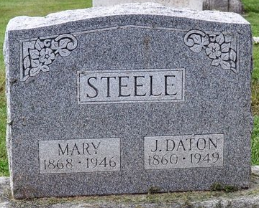
Photo by Deb Curry

MRS. MARY STEELE DIES LAST EVENING
Funeral Services Saturday Afternoon

Mrs. Mary A. Steele, 77, a resident of Adams County for 62 years, died at 6:15 o'clock Wednesday evening at her home one mile east of Decatur. Death, attributed to complications, followed an illness of three years. She had been bedfast for the past 12 weeks.
She was born in Berks County, Pa., August 18, 1868, the daughter of Jacob and Lavina Weiser-Drayer. She was married July 15, 1884 to J. D. Steele, who survives.
Mrs. Steele was a member of the First Presbyterian Church.
Surviving in addition to the husband are a brother, Edwin U. Drayer of Lauderdale, Pa., and a sister, Mrs. Amelia Swords of Reading, Pa. One daughter is deceased.
Funeral services will be held at 2:30 o'clock Saturday afternoon at the Zwick Funeral Home, with the Rev. J. W. McPheeters, Jr., officiating. Burial will be in the Decatur Cemetery. Friends may call at the funeral home after 2 p.m. Friday.

Decatur Daily Democrat; Adams County, Indiana
Thursday, May 2, 1946

