Lewis V. Steele
October 18, 1879 – January 30, 1904

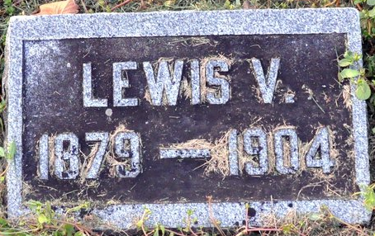
Photo by Deb Curry

Lewis V Steele
in the Indiana, U.S., Death Certificates, 1899-2017
Name Lewis V Steele
Gender Male
Race White
Marital Status Single
Age 24
Birth Date 18 Oct 1879
Birth Place Kirkland Tp Adams Co Indiana
Death Date 30 Jan 1904
Death Place Kirkland, Adams, Indiana, USA
Death Registration Date 1904
Father David Steele
Mother Marry E Hixson
Informant David Steele; Decatur, Indiana
Burial February 1, 1904; Beery Cemetery

