Levi Steele
February 9, 1818 – June 3, 1886

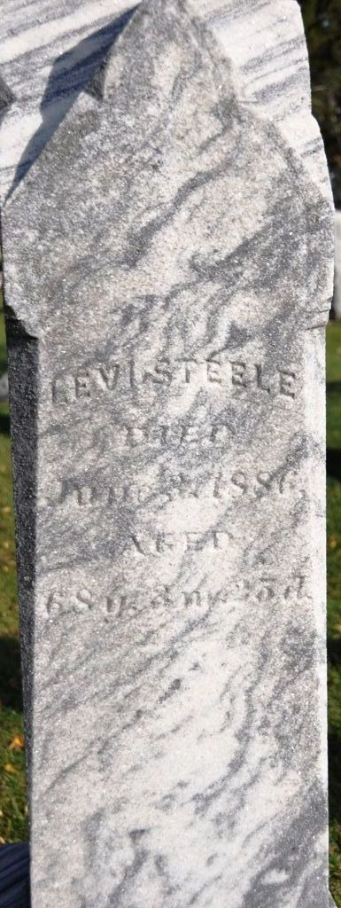
Photo by Deb Curry

Levi Steele from tree Seip/Steele Family Tree
Birth 9 Feb 1818 Bedford, Bedford, Pennsylvania, USA
Marriage 19 Oct 1837 Mohican, Ashland, Ohio, USA
Residence 1880 Adams, Indiana, USA
Death 3 Jun 1886 Adams, Indiana, USA
Father Jacob Dahlman Steele (1771-1837)
Mother Mary Elizabeth Smith (1774-1837)
Spouse Sarah Gelenline Valentine (1819-1893)

