Julia A. (Stephens) Steele
September 12, 1841 – April 15, 1875

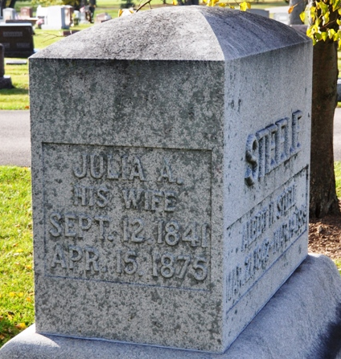
Photo by Deb Curry

Julia A Stevens from tree Wally's Family Tree
Birth 12 Sep 1841 Pennsylvania, USA
Residence 1860 Moline, Rock Island, Illinois, USA
Marriage 30 Nov 1865 Indiana, USA
Death 15 Apr 1875 Adams, Indiana, USA
Father Moses B Stephens (1807-1863)
Mother Lavina Howe (1812-1873)
Spouse Albert M. Steele (1842-1919)

